Week 3

Period: 6th

UNIT 2: CLOTHING
Section 1: GETTING STARTED - LISTEN & READ

I. OBJECTIVES:

Talk about the national dress of different countries in the word
II. LANGUAGE CONTENTS:
+ Vocabulary:
(V) mention, design, slit
(N) poem. poet, musician, material, fashion, ethnic minority, symbol
(ADJ) fashionable, trational, tunic, convenient
(ADV) trationally
+ Grammar:
present perfect tense

III. TECHNIQUES:
- Question & Answer
- Pair-work
- Group-work
IV. TEACHING AIDS
Textbook, pictures and flash cards
V. PROCEDURES:
(45 minutes)
New lesson:
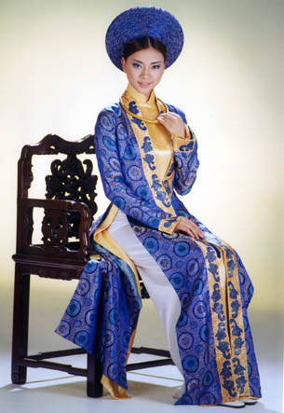
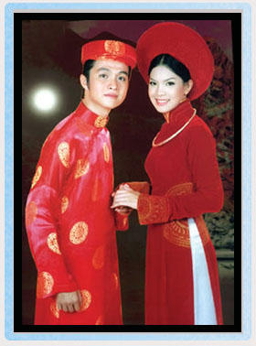

Section | Teacher’s activities | Students’ activities
Post - reading  Homework | - Playing game  - Divides class into groups. Asks Ss to look at the clothes people are wearing and take turn to decide where each person comes from  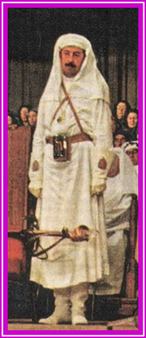  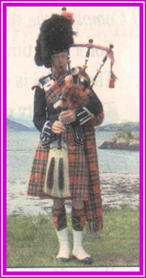  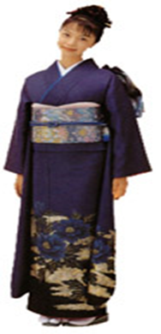  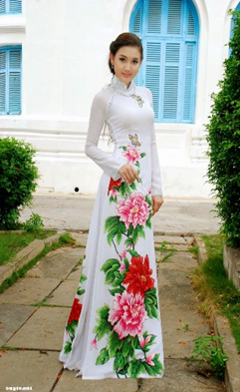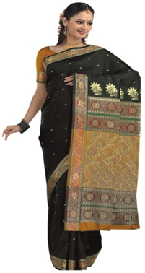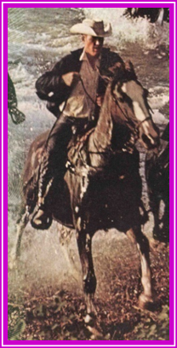  a/ Japan/ kimono  b/ Viet Nam/ ao dai  c/ Scotland/ kilt  d/ India/ sari  e/ The USA/ jeans  f/ Arabia/ veil  Example :  T: Where does the woman in picture a) come from? (she comes from Japan)  T: How do you know she come from Japan? (Because she is wearing a Kimono)  - the group who gives the correct answer gets a point  - Answers :  - She comes from Japan  - She comes from Vietnam  - He comes from Scotland ( UK )  ( He is wearing a kilt )  - She comes from India  ( she is wearing a sari )  - He comes from the USA  ( he is wearing jeans )  - She comes from Saudi Arabia  ( she is wearing a veil )  Lead-in: Picture a: She is from Vietnam because she is wearing the Ao dai. To know more about Ao dai, Vietnamese traditional women/s clothes, today we are going to learn Unit 2; Lesson 1.  - pre teach vocab :  - poet ( n) → poem (n) → poetry (a)  - long silk tunic ( n) ( translation )  - slit ( v) ( explanation )  - take inspiration from sth  - ethnic minorities ( example )  - pattern ( n) ( picture )  - tradition (n) → traditional (a) → traditionally (adv)  - fashion(n) → fashionable(a) → fashionable(adv)  - wear (v) ( wore, worn)  - Speaking :  - Asks Ss to use their own words to tell the group what they have known about the ao dai  - Learn new words by heart.  - Prepare section read. | - Play game (work groups)  - She comes from Japan  - She comes from Vietnam  - He comes from Scotland ( UK )  ( He is wearing a kilt )  - She comes from India  ( she is wearing a sari )  - He comes from the USA  ( he is wearing jeans )  - She comes from Saudi Arabia  ( she is wearing a veil )  - Repeat the new words chorally. Then write down  - poet ( n) → poem (n) → poetry (a)  - long silk tunic ( n)  - slit ( v)  - take inspiration from sth  - ethnic minorities  - pattern ( n)  - tradition (n)→ traditional (a) → traditionally (adv)  - fashion(n) → fashionable(a) → fashionable(adv)  - wear (v) ( wore, worn)  Work in individually

